**Sprint 1 - Matthew, Joseph & Andrea (Group 5)**

GitHub links

This here is the link for the repository for all our sprint coursework

* <https://github.com/mfal13/SECoursework>
* **Our Code of Conduct is inside our GitHub repo, under the Documentation folder. (**<https://github.com/mfal13/SECoursework/blob/main/Documentation/Code_of_conduct.md>)

This here is the link for our project for the sprint coursework

* <https://github.com/users/mfal13/projects/1>

**Docker screenshots**

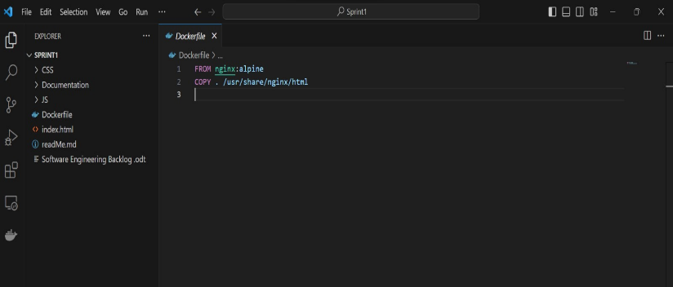Provided below are screenshots showing the use of a docker and it being used and functional.

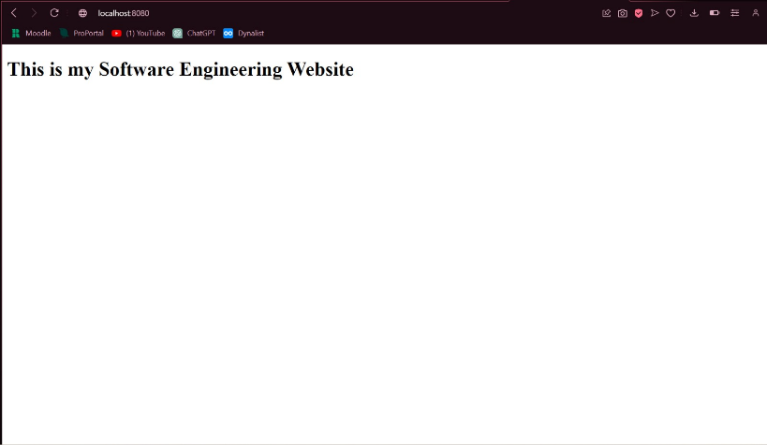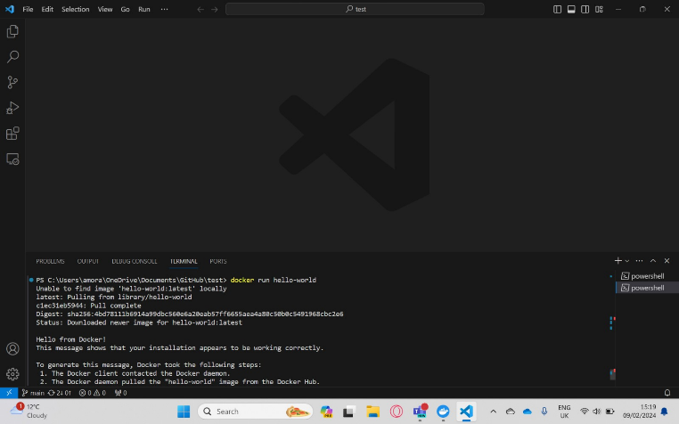

GitHub project / backlog

We added tasks that we need to complete for the next sprint into the backlog of the project’s kanban board. You can see the timeline of tasks being developed as they go through the different stages on the kanban board.

GitHub Branches

